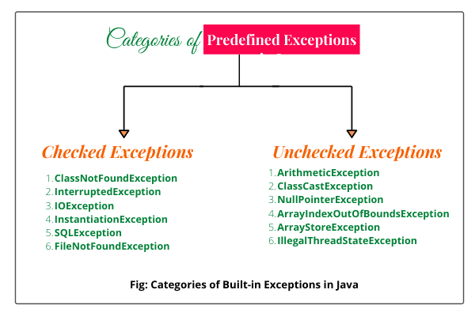

**ArrayIndexOutOfBoundsException**

**NullPointerException**

**StackOverflowError**

**ClassCastException**

**NoClassDefFoundError**

**ExceptionInInitializerError**

**IllegalArgumentException**

**NumberFormatException**

**IllegalStateException**

**AssertionError**

## **1. Java try...catch block**

try {

// code

}

catch(Exception e) {

// code

}

# **Java Exception Handling**

Example: Exception handling using try...catch

class Main {

public static void main(String[] args) {

try {

// code that generate exception

int divideByZero = 5 / 0;

System.out.println("Rest of code in try block");

}

catch (ArithmeticException e) {

System.out.println("ArithmeticException => " + e.getMessage());

}

}

}

O/P—: ArithmeticException => / by zero

## **2. Java finally block**

try {

//code

}

catch (ExceptionType1 e1) {

// catch block

}

finally {

// finally block always executes

}

### **Example: Java Exception Handling using finally block**

class Main {

public static void main(String[] args) {

try {

// code that generates exception

int divideByZero = 5 / 0;

}

catch (ArithmeticException e) {

System.out.println("ArithmeticException => " + e.getMessage());

}

finally {

System.out.println("This is the finally block");

}

}

}

O/P–:ArithmeticException => / by zero

This is the finally block

## **3. Java throw and throws keyword**

### **Example: Exception handling using Java throw**

class Main {

public static void divideByZero() {

// throw an exception

throw new ArithmeticException("Trying to divide by 0");

}

public static void main(String[] args) {

divideByZero();

}

}

O/P–:Exception in thread "main" java.lang.ArithmeticException: Trying to divide by 0

at Main.divideByZero(Main.java:5)

at Main.main(Main.java:9)

### 

### 

### **Example: Java throws keyword**

import java.io.*;

class Main {

// declareing the type of exception

public static void findFile() throws IOException {

// code that may generate IOException

File newFile = new File("test.txt");

FileInputStream stream = new FileInputStream(newFile);

}

public static void main(String[] args) {

try {

findFile();

}

catch (IOException e) {

System.out.println(e);

}

}

}

IOException-: IoException is a Checked Exception we can handle of the Try and catch,

IoException() is the a method return null value

**InterruptedException-:**

[**https://rollbar.com/blog/how-to-fix-the-array-index-out-of-bounds-excepiton-in-java/#**](https://rollbar.com/blog/how-to-fix-the-array-index-out-of-bounds-excepiton-in-java/#)

1).ArrayIndexOutOfBoundsException

Ans–:array in Java starts at index 0 and ends at index length - 1, so accessing elements that fall outside this range will throw an ArrayIndexOutOfBoundsException.

**public** **class** ArrayIndexOutOfBoundsExceptionExample {

**public** **static** **void** main(String[] args) {

String[] arr = **new** String[10];

System.**out**.println(arr[10]);

}

}

<https://rollbar.com/blog/how-to-catch-and-fix-nullpointerexception-in-java/#>

2).NullPointerException

Ans–:Calling methods on a null object

* Accessing a null object’s properties
* Accessing an index element (like in an array) of a null object
* Passing null parameters to a method
* Incorrect configuration for dependency injection frameworks like Spring
* Using synchronized on a null object
* Throwing null from a method that throws an exception

public class NullPointerExceptionExample {

private static void printLength(String str) {

System.out.println(str.length());

}

public static void main(String args[]) {

String myString = null;

printLength(myString);

}

}

## **How to Fix NullPointerException**

import org.apache.commons.lang3.StringUtils;

public class NullPointerExceptionExample {

private static void printLength(String str) {

if (StringUtils.isNotEmpty(str)) {

System.out.println(str.length());

} else {

System.out.println("Empty string");

}

}

public static void main(String args[]) {

String myString = null;

printLength(myString);

}

}

StackOverflowError

Ans–:StackOverflowError is **a runtime error which points to serious problems that cannot be caught by an application**.infinite recursion.

public class StackOverflowErrorExample {

public void print(int myInt) {

System.out.println(myInt);

print(myInt);

}

public static void main(String[] args) {

StackOverflowErrorExample soe = new StackOverflowErrorExample();

soee.print(0);

}

}

<https://rollbar.com/blog/how-to-solve-classcastexception-in-java/#>

3).ClassCastException

public class ClassCastExceptionExample {

public static void main(String[] args) {

Object obj = new String("Hello");

System.out.println((Integer) obj);

}

}

## **How to Fix ClassCastException**

public class ClassCastExceptionExample {

public static void main(String[] args) {

Object obj = new String("Hello");

if (obj instanceof Integer) {

System.out.println((Integer) obj);

} else {

System.out.println(obj);

}

}

}

**O/p—-:Hello**

[**https://rollbar.com/blog/java-no-class-def-found-error/#**](https://rollbar.com/blog/java-no-class-def-found-error/#)

4).NoClassDefFoundError

Ans–:

**class** Vehicle {

**private** String make;

**public** String getMake() {

**return** make;

}

**public** **void** setMake(String make) {

**this**.make = make;

}

}

**public** **class** NoClassDefFoundErrorExample {

**public** **static** **void** main(String args[]) {

Vehicle vehicle = **new** Vehicle();

vehicle.setMake("Audi");

System.**out**.println("Make = " + vehicle.getMake());

}

}

https://rollbar.com/blog/java-exceptionininitializererror-runtime-error/#

5).ExceptionInInitializerError

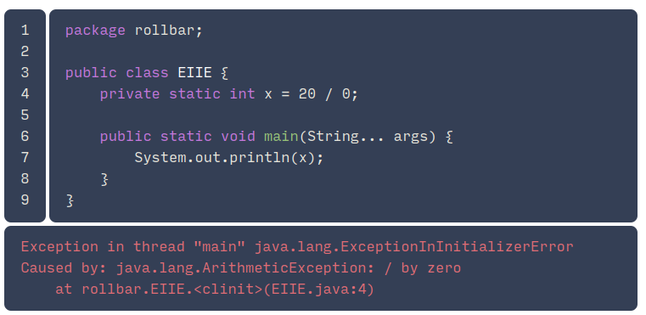

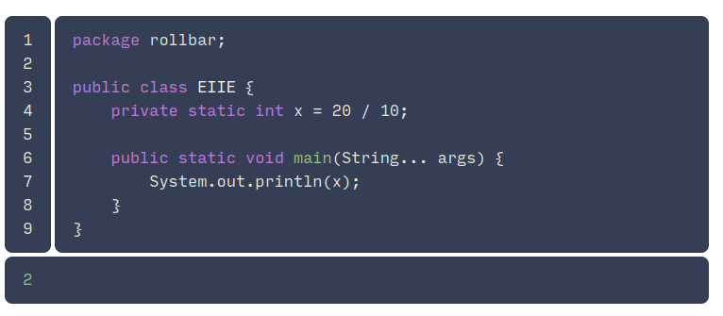

### **Unchecked exception inside static initializer**

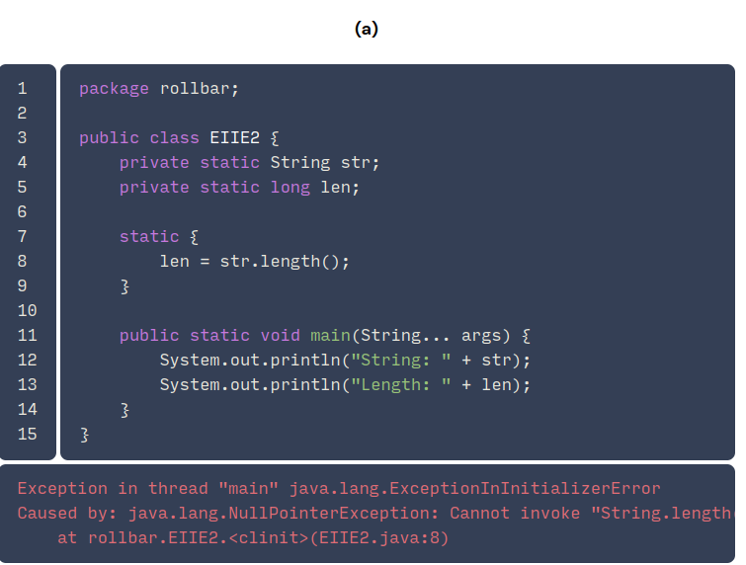

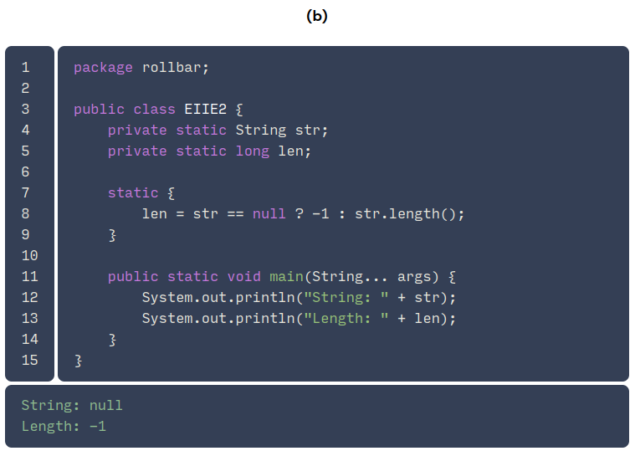

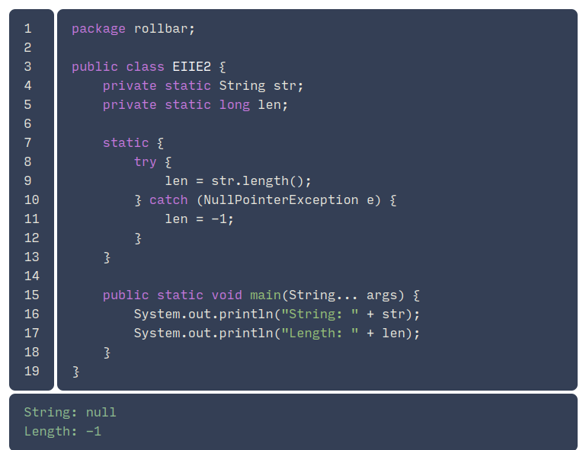

<https://rollbar.com/blog/how-to-throw-illegalargumentexception-in-java/#>

6).IllegalArgumentException

Ans–:IllegalArgumentException code> **occurs when an argument passed to a method doesn't fit within the logic of the usage of the argument**.

public class Person {

int age;

public void setAge(int age) {

if (age < 0) {

throw new IllegalArgumentException("Age must be greater than zero");

} else {

this.age = age;

}

}

public static void main(String[] args) {

Person person = new Person();

person.setAge(-1);

}

}

<https://rollbar.com/blog/java-numberformatexception/#>

7).NumberFormatException

Ans–:

<https://rollbar.com/blog/java-illegalstateexception/#>

8).IllegalStateException

Ans–::An IllegalStateException is **a runtime exception in Java that is thrown to indicate that a method has been invoked at the wrong time**

import java.util.ArrayList;

import java.util.Iterator;

public class IllegalStateExceptionExample {

public static void main(String args[]) {

ArrayList<String> list = new ArrayList<String>();

list.add("a");

list.add("b");

list.add("c");

Iterator<String> it = list.iterator();

it.remove();

}

}

## **How to Fix IllegalStateException**

import java.util.ArrayList;

import java.util.Iterator;

public class IllegalStateExceptionExample {

public static void main(String args[]) {

ArrayList<String> list = new ArrayList<String>();

list.add("a");

list.add("b");

list.add("c");

Iterator<String> it = list.iterator();

it.next();

it.remove();

System.out.println(list);

}

}

9).AssertionError

Ans–:AssertionError is that **something happened that the developer thought was impossible to happen**.

public class Example {

public static void main(String[] args) throws Exception {

try {

assert args.length > 0;

}

catch (AssertionError e) {

System.out.println(e.getMessage());

}

}

}